Software Design Specification



Project Code:
BS-212332

Internal Advisor:
Dr. Hafiz Faisal Shehzad

Project Manager:
Dr. Muhammad Illyas

Project Team:
Sr. No | Name | Roll No | Role
1. | Saba Raffique | BSEF19M023 | Team Leader
2. | Iqra Ikram | BSEF19M021 | Team Member
3. | Muhammad Nazim | BSEF19M032 | Team Member

Submission Date:

_____________________
Project Manager’s Signature

Document Information

Category | Information
Customer | Department of CS & IT
Project | WideHeaven(Online Clothing Store)
Document | Software Design Specification
Document Version | 1.0
Identifier | BS-212332
Status | Draft
Author(s) | Iqra Ikram, Saba Raffique, Muhammad Nazim
Approver(s) | PM
Issue Date | Sept. 15, 2022
Document Location
Distribution | - Advisor  - PM  - Project Office

Definition of Terms, Acronyms and Abbreviations

Term | Description
SRS | Software requirement specification
OSS | Online shopping system
SDLC | Software Development life cycle
CUST | Customer
VP | Verify Payment`
HTTP | Hypertext Transfer Protocol
CSS | Cascading Style Sheet
HTML | Hyper Text Markup Language

Table of Contents

1. Introduction 4
1.1 Purpose of Document 4
1.2 Project Overview 4
1.3 Scope 4
2. Design Considerations 4
2.1 Assumptions and Dependencies 4
2.2 Risks and Volatile Areas 4
3. System Architecture 4
3.1 System Level Architecture 4
3.2 Sub-System / Component / Module Level Architecture 5
3.3 Sub-Component / Sub-Module Level Architecture (1…n) 5
4. Design Strategies 5
4.1 Strategy 1…n 5
5. Detailed System Design 5
6. References 6
7. Appendices 6

Introduction

  - Purpose of Document
The WideHeaven store allows visitors to collect items in a virtual shopping cart. They may view the contents of their shopping cart at any time and may add or delete items at will. The program automatically calculates the subtotal, shipping charges, and total. This is software that helps you to do the major part of online shopping by using this site and can be managed online you (or the customer) can securely do all major transactions. To ensure the authentication of the customer one must have to register before proceeding. It provides the following standard features of any e-commerce website.

  - Project Overview
The purpose of the document is to define the system, and its requirements consuming consumers, admin, and sellers. In addition, the purpose of this design document is to provide a detailed overview of our software product, its parameters, and its goals. This document describes the project's target audience and its user interface, hardware, and software requirements. It defines how our customers, admin, sellers, and audience see the product and its functionality. Traders, distributors/marketers can sell products/services and the customer can purchase on that website electronically by using the internet on a mobile and computer.

  - Scope
We will provide all brand-new clothes with detailed specifications and customers can search sales of all brand’s products on one page. We will provide the service of delivery. This project also provides security with the use of Login-id and Password, so that any unauthorized users cannot use your account. Only Authorized will have proper access authority can access our web app. This system allows the customers to maintain their cart to add or remove the products over the internet. We will not provide service of replicated and old products selling.

Design Considerations
The consideration related to design of the project including assumptions and dependencies are provided with the possible risks and violate areas.

  - Assumptions and Dependencies
It is assumed that the hardware designed will work correctly with the third-party operating system and the developed software. We assume that the customer has a computer or a smart phone with a browser and has internet.

  - Risks and Volatile Areas
Any time customers consider purchasing a new product or service, they face a set of uncertainties about the product or service collectively referred to as perceived risk. The level of uncertainty of a consumer depends upon whether the purchase one making will be worth it or not. Every time a consumer considers buying product, he or she has certain doubts about the product, especially if the product in question is highly priced
- Functional Risks: It refers to the fear that a product or service will fail to deliver promised services or benefits.
- Social Risks: It pertains to a consumer's social status. Person of a high or wealthy social class, they want to buy products that their friends would also buy.
- Financial Risks: Every consumer is afraid that a purchase might strip them of their income sources at that time or in the future.
- Physical Risks: An item that could cause bodily harm to a person or their family causes perceived risk.
- Time Risks: If a product breaks or fails a few days after purchase and need replacement, this is time risks.
- Psychological Risks: Consumers also face questions about whether a given purchase is the morally right choice.

System Architecture

  - System Level Architecture
Deployment diagram
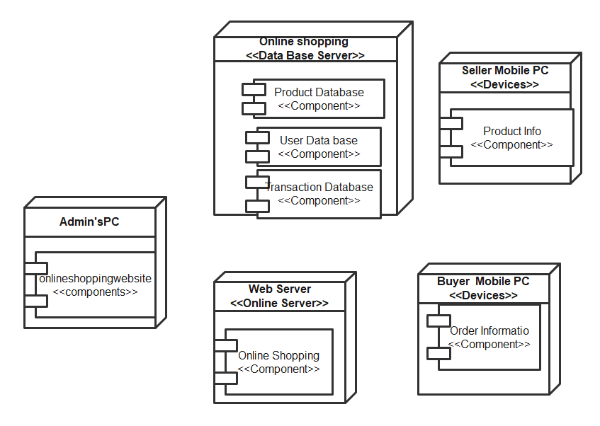

  - Sub-System / Component / Module Level Architecture
Component diagram

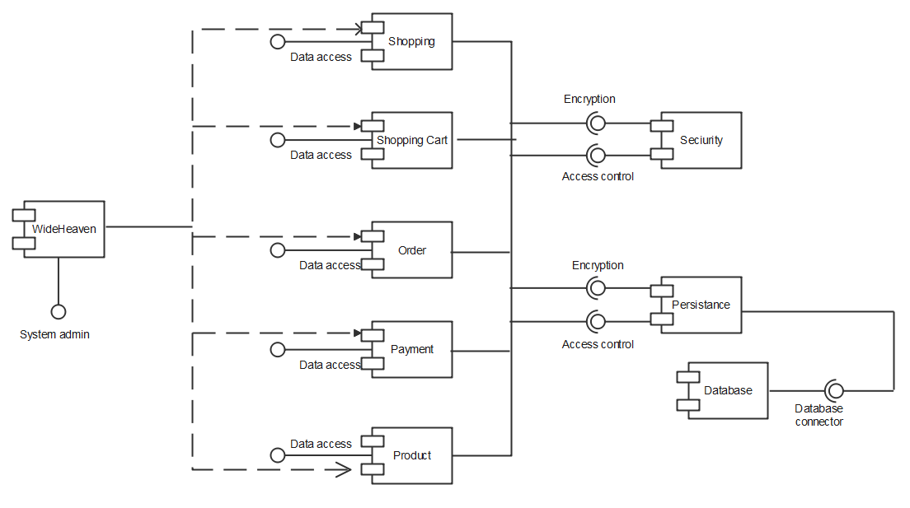

  - Sub-Component / Sub-Module Level Architecture (1…n)
Identify all the sub components or sub modules (if any) of the already identified modules and components. Provide their diagrammatic view using appropriate detailed architecture diagram presenting how those sub systems, modules and components are further divided into sub components and sub modules and how they interact with each other.

Design Strategies
Describe the design strategies or decisions that impact the overall organization of the system and its high-level structures. This information should provide the reader with insights into the key abstractions and mechanisms used in the system architecture.

  - Strategy 1…n
For each strategy, discuss the reasoning employed (possibly referring to previously stated design goals and principles) and any trade-offs. Areas for consideration include:

- Future system extension or enhancement
- System reuse
- User interface paradigms
- Data management (storage, distribution, persistence)
- Concurrency and synchronization

Detailed System Design
  - DFD (0 Level/Context Level)

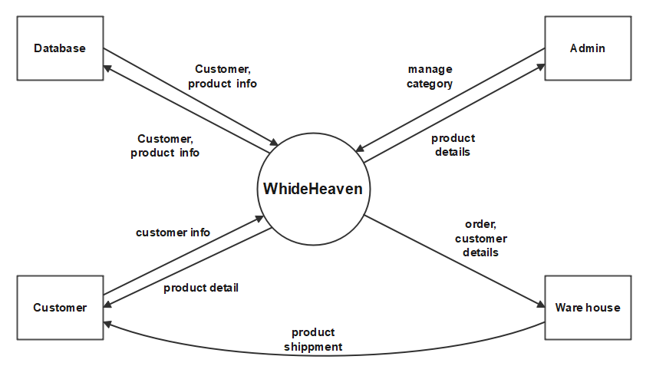
  - DFD (1 Level)
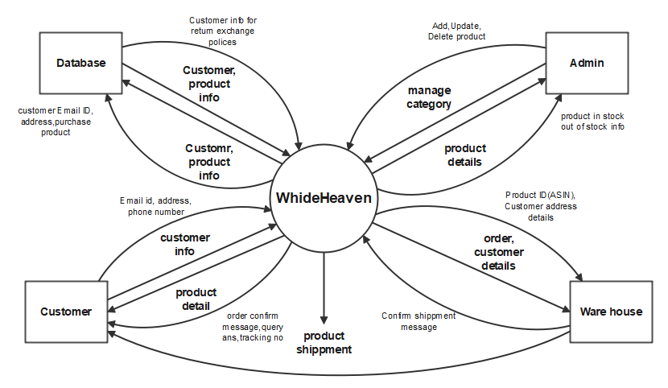

  - ER Diagram
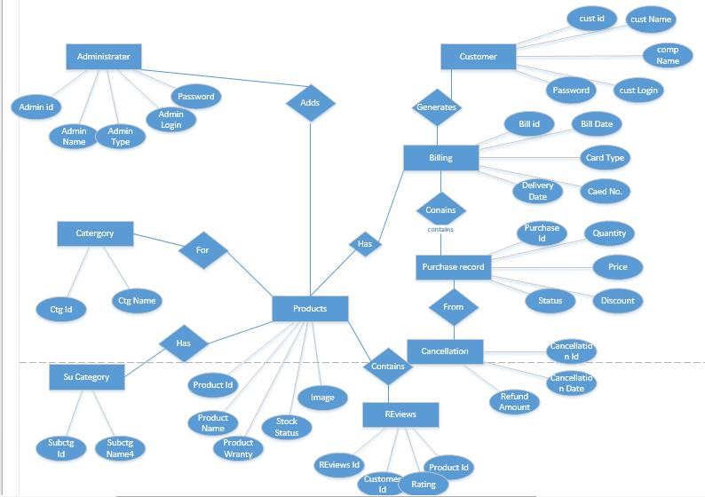

  - Use Case Diagram
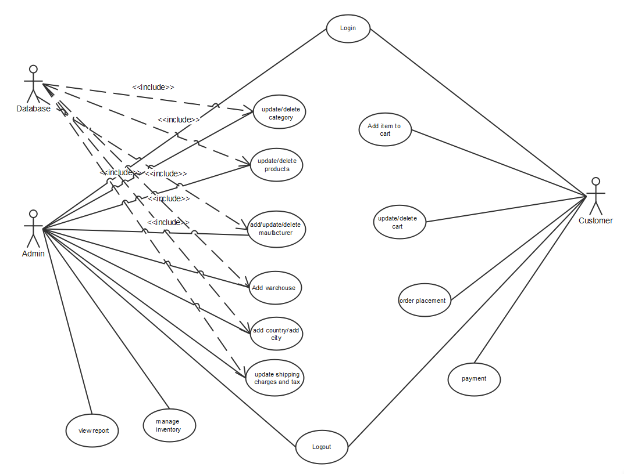
  - Class diagram
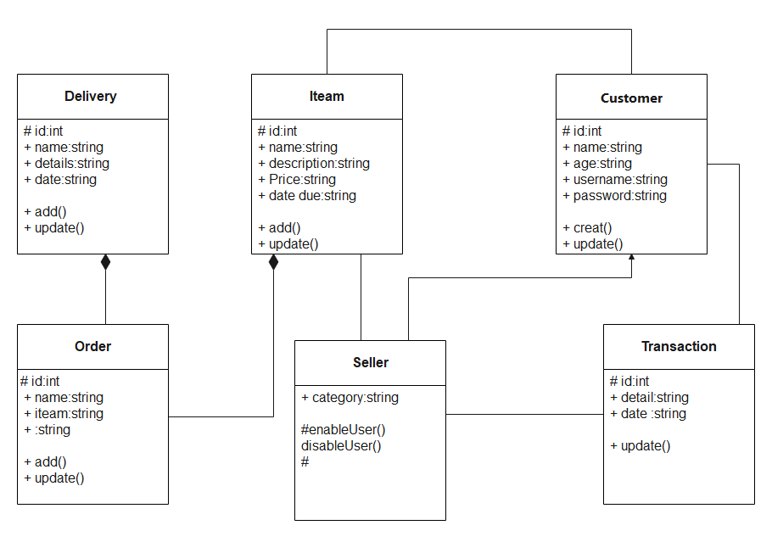

  - Activity diagram
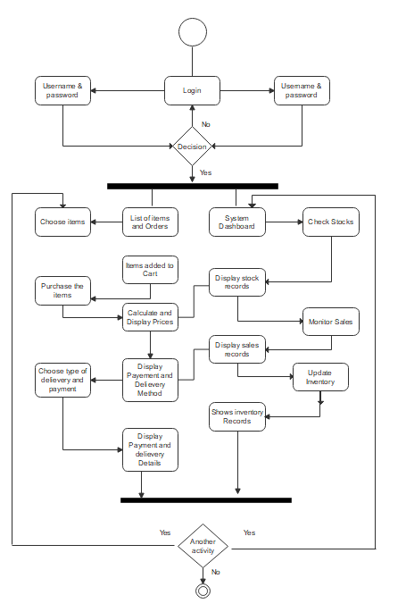
  - State diagram
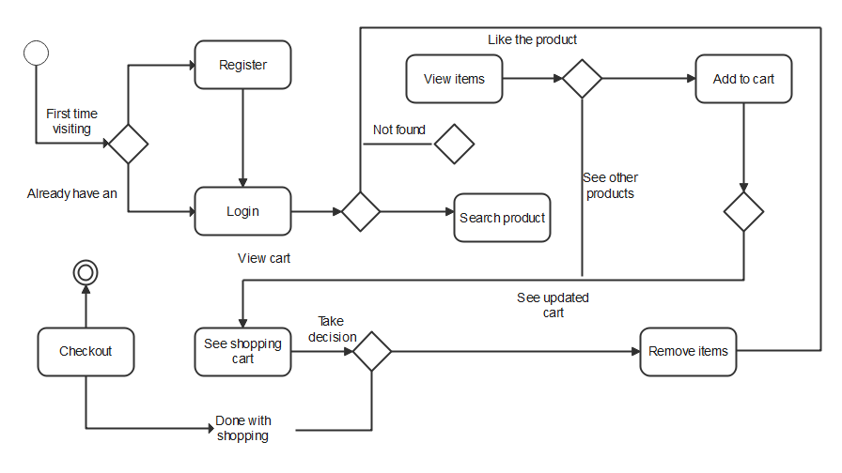

References
This section should provide a complete list of all documents referenced at specific point in time. Each document should be identified by title, report number (if applicable), date, and publishing organization. Specify the sources from which the references can be obtained (This section is like the bibliography in a published book).

Ref. No. | Document Title | Date of Release/ Publication | Document Source
PGBH01-2022-Proposal | Project Proposal | Oct 20, 2022 | <Give the path of your Project repository/Folder>
PGBH01-2022-FS | Functional Specification | Oct 20, 2022 | <Give the path of your Project repository/Folder>

